Objemy a povrchy telies
Teleso | Obrázok | Objem | Povrch
Kocka | 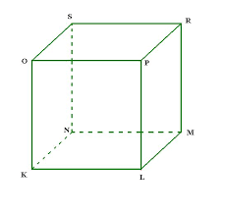 | V = a³ | S = 6.a²
Kváder | 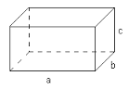 | V = a.b.c | S =2(ab+bc+ca)
Kolmý hranol | 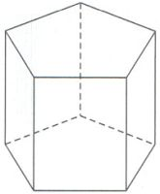 | V = S_{p}.v | S = 2.S_{p} + S_{pl}
Ihlan | 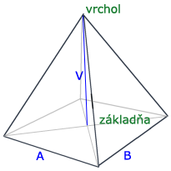 | $$V=\frac{1}{3}S_{p}.v$$ | S = S_{p} + S_{pl}
Zrezaný ihlan | 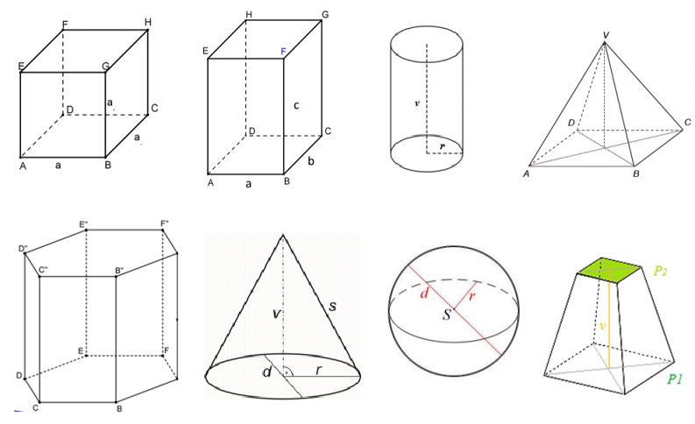 | $$V=\frac{v}{3}(S_{p1}+\sqrt{S_{p1}.S_{p2}}{+S}_{p1})$$ | S = Sp1 +Sp2+Spl
Valec | 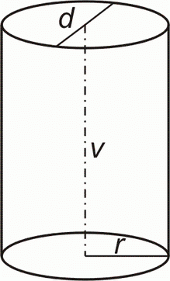 | V = π.r².v | S = 2.πr.(r+v)  Spl= 2.πr.v
Guľa | 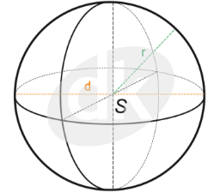 | $$V=\frac{4πr^{3}}{3}$$ | S = 4 πr²
Kužeľ | 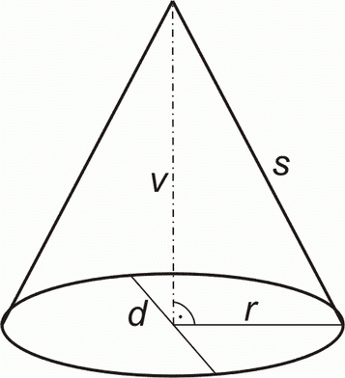 | $$V=\frac{πr^{2}v}{3}$$ | S = πr.(r+s)  Spl= πr.s
Zrezaný kužeľ | 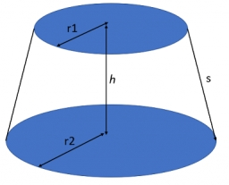 | $$V=\frac{πv}{3}({r_{1}}^{2}+r_{1}r_{2}+{r_{2}}^{2})$$ | S = πr₁² + πr₂²  + π(r₁ r₂).s

